**“Experiment 1.1”**

Student Name: **SUMIT KUMAR** UID: **20BCS8226**

Branch: **CSE** Section/Group: **808 A**

Semester: **5**  Date of Performance: **05-08-22**

Subject Name: **Multimedia Technologies Lab** Subject Code: **20CSP-339**

**1. Aim/Overview of the practical:**

Design a Visiting Card containing at least one graphics and text information.

**2. Which logistics used:**

Hardware Requirements: - Minimum 384MB RAM, 100 GB hard Disk, processor with 2.1 MHz

Software Requirements: - Photopea

Tools Used: - Type Tool, Magic Wand, Lasso select.

**3. Steps for experiment/practical/Code:**

**Step1:** Create new project on Photopea, and specify dimensions as required.

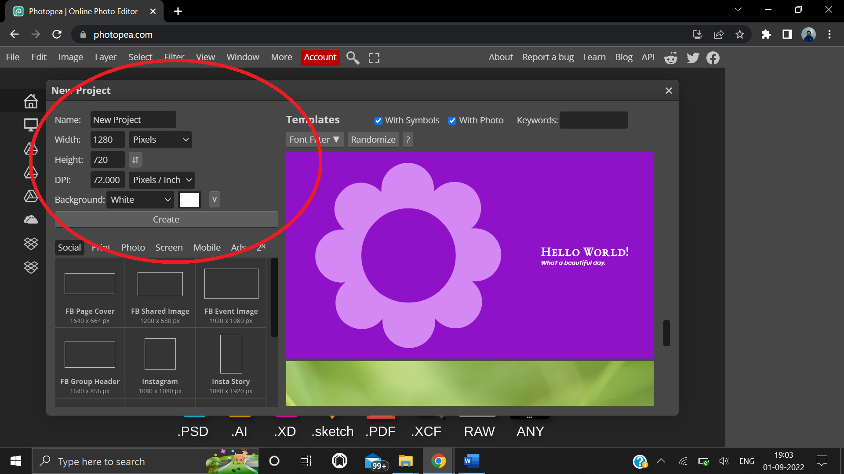

**Step 2:** Add background image by copying and pasting from internet or uploading local file from the file menu.

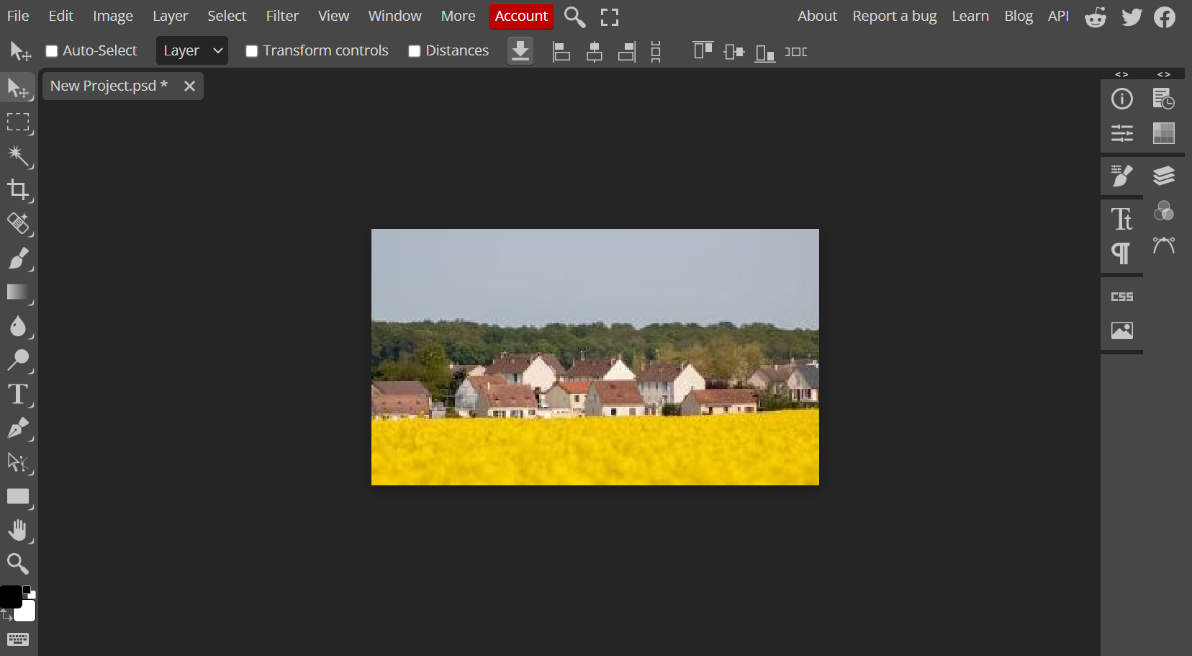

**Step 3:** Add name and details of visiting card using type tool.

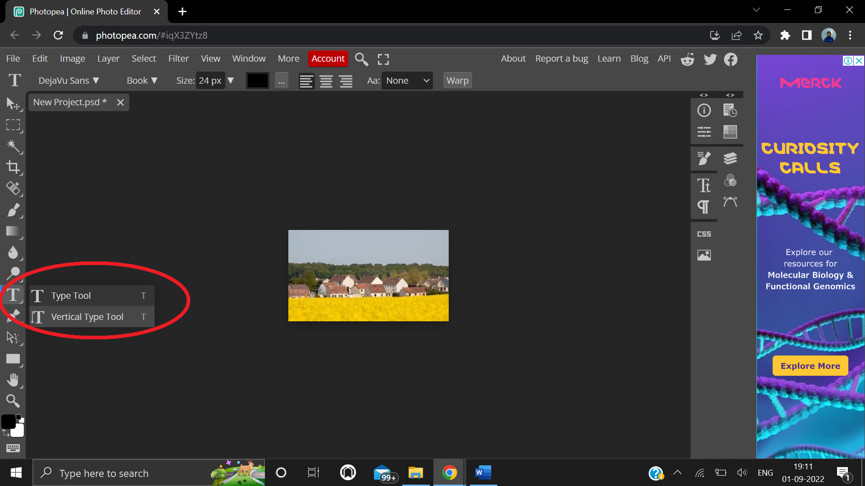

**4. Result/Output/Writing Summary:**

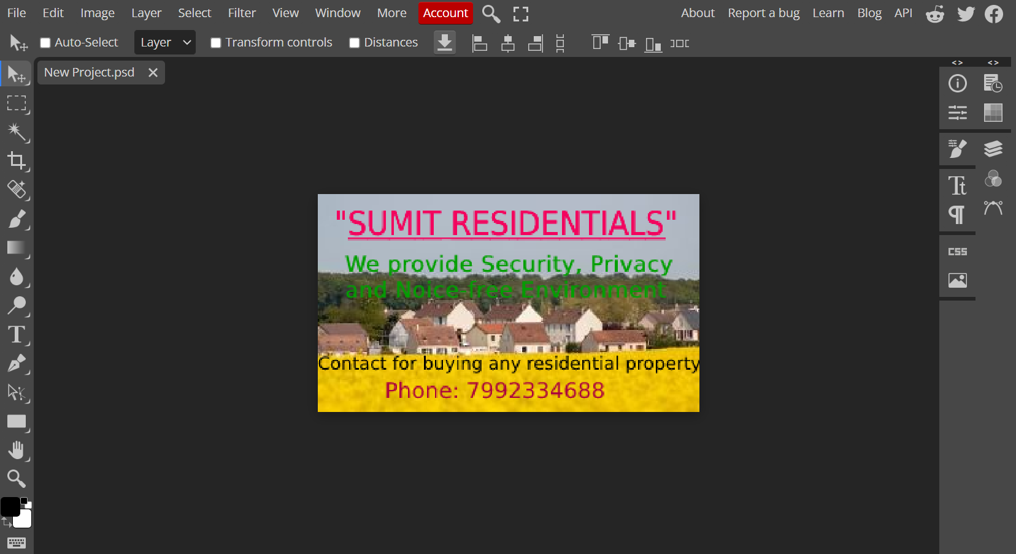

**Image after adding text**

**Learning outcomes (What I have learnt):**

**1.** Learnt how to select and operate on portions of image using lasso tool.

**2.** Learnt how to remove an object while preserving background using content aware fill.

**Evaluation Grid (To be created as per the SOP and Assessment guidelines by the faculty):**

|  |  |  |  |
| --- | --- | --- | --- |
| Sr. No. | Parameters | Marks Obtained | Maximum Marks |
| 1. |  |  |  |
| 2. |  |  |  |
| 3. |  |  |  |
|  |  |  |  |